3.Perform basic Image Handling and processing operations on the image is to read an image in python and Convert an Image to show outline using Canny function.

**AIM:**

To read an image and apply edge detection using the Canny function in OpenCV with Python.

**PROCEDURE:**

1. Install OpenCV (if not already installed):pip install opencv-python
2. Import required libraries:Use cv2 for image processing.
3. Read the image:Use cv2.imread() to load the image.
4. Convert the image to grayscale:Use cv2.cvtColor() with the cv2.COLOR_BGR2GRAY parameter.
5. Apply Canny edge detection:Use cv2.Canny() with appropriate threshold values.
6. Display the images:Use cv2.imshow() to show both original and edge-detected images.
7. Wait for a key press & close windows:
8. Use cv2.waitKey(0) to keep the image open until a key is pressed.
9. Use cv2.destroyAllWindows() to close all image windows.

**PROGRAM:**

import cv2

image = cv2.imread(r"C:\Users\sr051\OneDrive\Desktop\ITA0504-CV\tree.jpg")

if image is None:

print("Error: Image not found or path is incorrect.")

else:

gray = cv2.cvtColor(image, cv2.COLOR_BGR2GRAY)

edges = cv2.Canny(gray, 100, 200)

cv2.imshow("Original Image", image)

cv2.imshow("Edge Outline", edges)

cv2.waitKey(0)

cv2.destroyAllWindows()

**INPUT:**

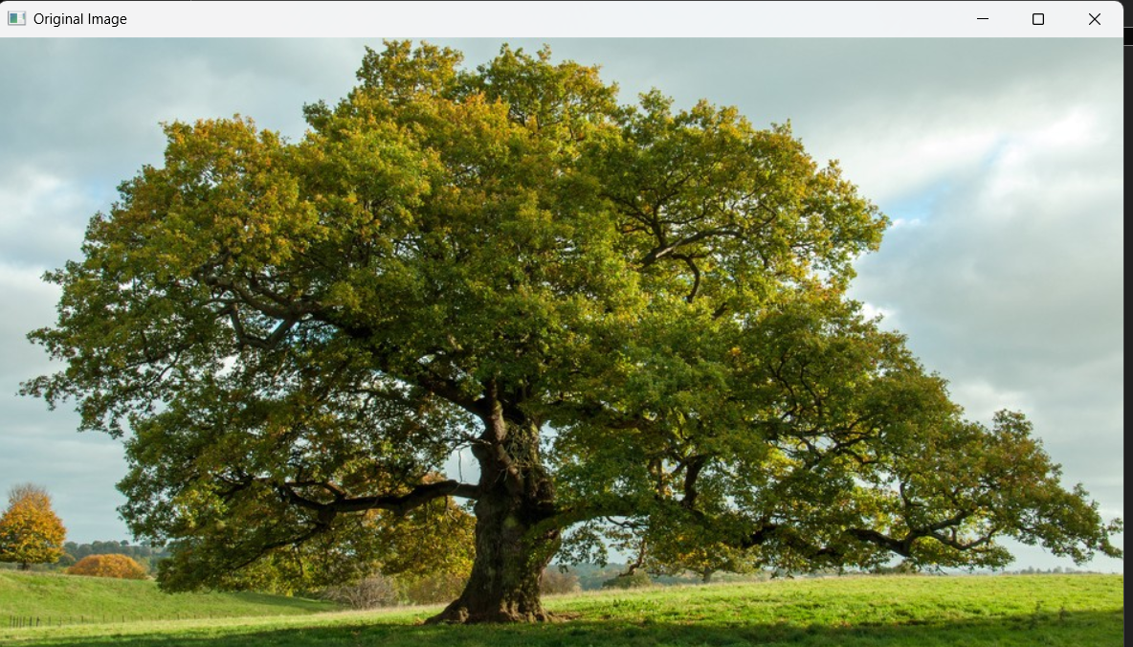

**OUTPUT:**

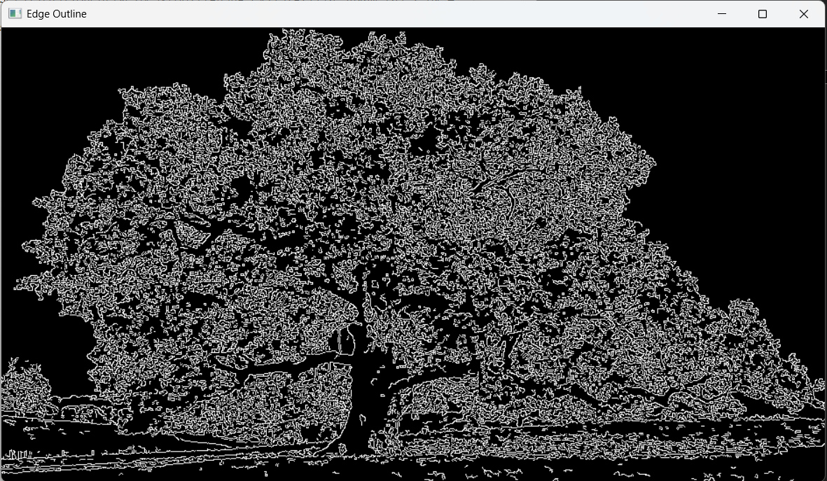

**RESULT :**

Successfully read the input image and applied edge detection using the Canny function in OpenCV.